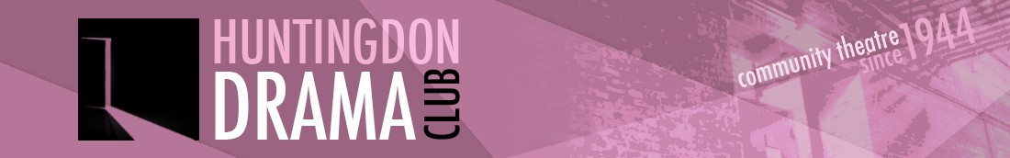

COMMITTEE MEETING MINUTES
Tuesday 2nd May 2017
York Close, Godmanchester

Present: Jo Hussey, Chair (JH), Graham Crouch (GC), Marion Stribling (MS), Dean Laccohee (DL), Caroline Molony (CM), Michelle Gibson (MG), Edd Welsh (EW), Rae Goodwin (RG), Sarah Cornforth (SC), Vicky Spurway (VS)

1. Minutes of the Last Meeting (4th April)
Riverside Gala:
- MS confirmed the space had been booked.
- It was agreed to set up at 10.30am and have a rota of 2 people per hour until 4pm. EW would put together the rota, DL would ask for volunteers via the newsletter.
- JH/DL would collect the display board from Alconbury.
- DL would provide SC with the access code for club photos.
- DL/VS to speak to cast about attending the Gala.

JH thanked everyone for their help with the move from the Hall which went smoothly and to Bob for hiring and driving the van.

SC reported that she has made contact with St Peter’s School and was waiting to hear back. CM would look into the use of the Officers Mess at Brampton.

There were no matters arising from the minutes. The minutes were agreed as correct.

2. Summer Production
VS reported that the rehearsals had started. A small group were going to Beverley on 20/5 for the matinee performance of Shakers which is being put on by the John Godber Company.

DL reported that after looking at hire costs and potential ticket sales it was decided to put on 4 shows, Wed-Sat, and to cancel the matinee performance. There were 86 seats available for each performance, 23 tickets had been sold so far.

3. Treasurer’s Report
GC reported that the bank balance at 30/4 was £7008. The total income from Alfie was £4346 with expenditure of £3107. Alfie had made a profit of £1238, with a few more expenses to be reimbursed. This compared to £525 for “George”.

GC reported that the total for the AV/lighting fund from online donations and proceeds from raffles for Edge and Alfie was £596.53. With the grant from the Freemans Charity, the AV/lighting fund was over £2000. The equipment would need to be purchased for Shakers.

4. Cambs Drama Festival
DL reported that the Club had performed excerpts from Alfie at the Drama Festival the previous Thursday. The club had put on a fantastic performance which had been reflected in 3 nominations for Best Actress, Best Actor and Best costumes. DL added it had been a very positive experience and the adjudicator had given the performance a great review. DL hoped that next year the club would put together a production for the festival rather than excerpts of the spring production.

5. Riverside Gala
The arrangements for the Gala were covered earlier in the meeting.

6. Christmas Party
JH said that the club had held dinner/dance events for the last couple of years and she felt there was now a big enough membership to arrange our own Xmas party. It was suggested that the club could hire Hartford village hall and bring our own food. DL had offered to DJ and we could possibly arrange for the King of the Belgians to run a bar. The committee felt this was a good idea and would be more affordable for members. It was agreed to go ahead with this approach. MS would check room hire costs and availability.

7. Update Reports
Social
DL reported that Sandra Bernie would be directing The Thrill of Love by Amanda Whittington for the Club’s spring 2018 production. Sandra would like to do a play reading evening for the play.

VS reported that in preparation for Shakers, there would be a club outing to Rock Lobster in Cambridge on 17/6 for an 80’s disco night!

9. AOB
Shakers – FOH
MS asked if there were plans to have club members as bouncers for the Shakers production. VS said this had been considered and thought it was a good idea. DL would ask for “bouncer” volunteers via the newsletter.

Ellington Village Fate, 25th June
GC requested, on behalf of the Ellington village fate, for a pair of tickets as raffle prizes. It was agreed to provide a pair of tickets for Shakers. GC would take flyers to the event to promote the show.

Next meeting
The next meeting would take place on Tuesday 6th June at York Close. Godmanchester.

Summary of Actions Agreed

Who | What | When | Comment
EW  DL  DL  JH/DL  DL  SC  MS  DL/VS | Riverside Gala Actions– 10/6/17  Co-ordinate the arrangements and rota for the day  Request volunteers via newsletter  Provide a Gazebo  Display board to be collected from Alconbury  Give SC access to online club photos  Put together photos for the display board  Produce and print newsletter sign up forms  Contact cast members | In time for the Gala
SC | Contact St Peter’s School for site visit | ongoing
CM | Investigate use of Lookers Barn at Godmanchester and also Officers Mess at Brampton | ongoing
All | Keep thinking about potential venues | ongoing
All | Ideas for rehearsal space needed. | Next meeting/  ongoing
MS | Check cost and availability of Hartford Village Hall for Xmas party | Next meeting
DL | Request for Shakers “bouncers” via newsletter | For production

