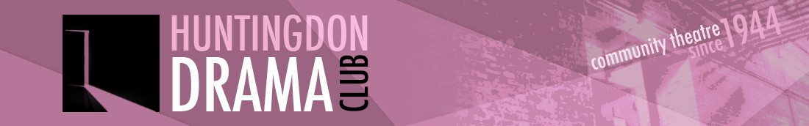

COMMITTEE MEETING MINUTES
Tuesday 5th September 2017
York Close, Godmanchester

Present: Jo Hussey, Chair (JH), Marion Stribling (MS), Dean Laccohee (DL), Caroline Molony (CM), Michelle Gibson (MG), Edd Welsh (EW) Graham Crouch (GC), Rae Goodwin (RG), Sarah Cornforth (SC)

1. Minutes of the Last Meeting (11th July)
- DL would discuss audition and rehearsal dates for the spring production with Sandra.
- Radio interview dates to be added to the Crucible rehearsal schedule – HCR the Friday before the production at 9pm. BBC Cambs interview would be during the day. DL would follow up interest from BBC Look East.
- RG reported that she would take forward the workshop after Xmas.
  - JH added that David Hall had asked to borrow some costumes and had offered to put on a workshop for free in return. It was agreed it would be beneficial to hold his workshop before the Crucible. JH would check dates with David Hall. RG to consider what would be useful to include in the workshop.
- DL reported that All Saints Church had been booked for 21-24th March.

There were no matters arising from the minutes. The minutes were agreed as correct.

2. Summer Production
Overall Shakers had made a £150 loss, which the committee agreed was not a bad outcome. The venue had been challenging and seating had caused some problems. It was agreed to include a “meet and greet” person on the FOH rota to help with welcoming and directions. The performances had been very good and received good feedback. It was noted that there had been an increase in walk-ins as the week went on.
JH added that the Noda review had been very good and congratulated everyone involved in the production.

3. Treasurer’s Report
GC reported that there was £6651 in the bank. The Freemans grant had been paid in along with ticketsource revenue for Shakers and a subscription payment from an unknown member. JH would look into who had joined.

4. Autumn Production
RG reported that the Crucible had been fully cast and almost had a full crew. RG was still looking for someone to oversee costumes.
The first rehearsal had taken place, RG reported that it was proving tricky getting all the cast together. RG would check the room bookings with the Town Hall.

SC was working on the photo for the poster and said it would be ready by Mon/Tue of next week.

DL reported that the seating plan was in place and it was agreed for tickets to go on sale ASAP for members only for a week. Tickets would then go on general sale. DL would send newsletters with the ticket information and include a hyperlink to explain “in the round”.

5. Future Productions / Gala Performances
JH reported that she had been approached by Jane Crittenden with a request for the club to host a gala night on behalf of Pinpoint charity. The committee discussed the request and agreed that the club was not in a position to host a charity event until productions were back in the refurbished Commemoration Hall. JH would reply to Jane with the committee’s decision and offer the charity space in the Crucible programme.

RG suggested offering advertising space in the programme to help with production income. RG would discuss with the production team.

The committee discussed the issue of reducing the number of shows. It was agreed to defer any decisions until after the Crucible.

6. Storage / SIMADS Hut
JH reported that the contract for the storage facility at Alconbury had been extended to February 2018.
JH had been contacted by SIMADS about space in their storage hut. There was some confusion as no one on the committee had requested help from SIMADS. JH would talk to Phil at SIMADS about storage.

7. Social Update
The play reading for The Thrill of Love would take place on 11th October at the Falcon. It was agreed to hold David Hall’s workshop instead of an autumn social. The Xmas party had been booked for 8th December.

8. AOB
Collaboration with other Drama groups
RG requested to add an item on the next agenda to discuss closer working with the three drama groups in Huntingdon.

Caroline Molony
CM announced that this would be her last committee meeting as she was stepping down. JH thanked CM for all her work on the committee.

Codebreakers and Groundbreakers
SC thought the committee might be interested in the Codebreakers and Groundbreakers exhibition which was taking place at the Fitzwilliam Museum, Cambridge, 24th Oct – 4th Feb.

Summary of Actions Agreed

Who | What | When | Comment
DL | Liaise with Sandra regarding audition/rehearsal dates for spring production | Next meeting
Crucible production team | Add radio interview dates to rehearsal schedule | Next meeting
DL | Follow up interest from BBC Look East | Next meeting
JH/RG | JH to check dates with David Hall for a workshop. RG to give thought to workshop content. | ASAP
MS | Add “meet and greet” person to FOH rota. | Next production
JH | Look into unknown subscription payment. | ASAP
RG | Check Crucible room bookings with the Town Hall | ASAP
SC | Provide photo for poster by next week. | 12th Sept
DL | Send newsletters for Crucible ticket information | ASAP
JH | Reply to Jane regarding Gala night decision and offer space in the programme for Pinpoint. | Next meeting
RG | Discuss advertising options in the programme with production team | Next meeting
JH | Contact Phil at SIMADS about storage at their hut. | Next meeting
MS | Add “Collaboration with drama groups” item on next agenda | Next meeting
RG | Take forward a club workshop following the RSC weekend | Ongoing (after Xmas)

